Climate Clever Communities Challenge Fund Guidelines

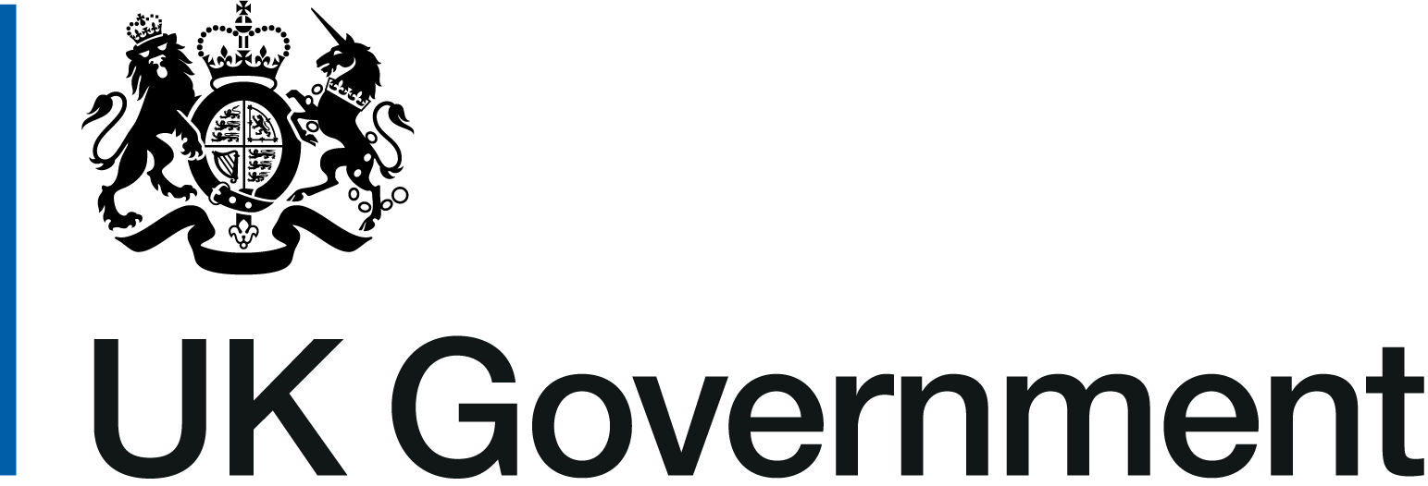
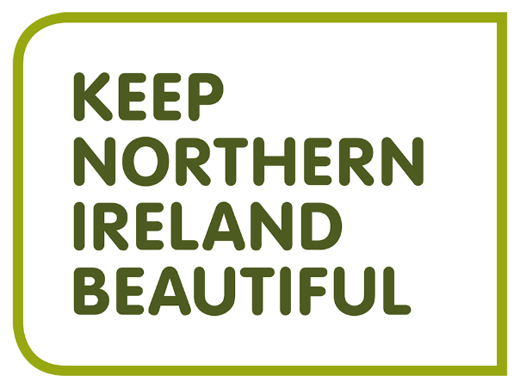

March 2022

Introduction
The Climate Challenge Fund is a key part of the Climate Clever Communities project being delivered by Keep Northern Ireland Beautiful and funded by the UK Community Renewal Fund.
The UK government’s Net Zero Strategy reflects the urgency at which action is required to get climate change under control, seeking to cut emissions to net zero by 2050. To reach these targets there is a real need to educate and prepare local communities and businesses in Northern Ireland (and across the UK) on the impacts and consequences of climate change and then empower them to take positive practical individual and collective action. To do this we first need to create a climate and carbon literate society.
Carbon Literacy training raises awareness about carbon emissions linked to everyday activities, actions and processes. In the process, it raises awareness of the impacts of climate change in NI as well as at a global level, outlines issues related to climate justice, examines aspects of the legislative response in NI and beyond, as well as raising the profile of actions we can all take that can help to reduce emissions. The training aims to bring broad sectors of society in to the climate change discussion, hear a range of views and to find a way for all communities and individuals to feel a sense of agency in this challenge to find effective solutions.
The Climate Challenge Fund supports you as you put your climate change knowledge into practical action and maximises community participation in local climate conversations. You can do this by trialling new innovative pilot projects that are appropriate to your neighbourhood in order to cut carbon emissions and improve the quality of your local place.
- Eligibility
The Climate Challenge Fund is open to:
- Unconstituted groups
- Volunteer, community groups and NGOs
- All schools and third level education organisations
- Youth groups and sports clubs
- Not for Profit Organisations
- Sports clubs, tenants and residents associations and religious groups
- Local Councils
- Businesses
- Applications are particularly welcome from groups who have completed the Carbon Literacy training (with Keep Northern Ireland Beautiful or other training provider)
The project should:
- Involve and benefit your local community
- Increase your community’s understanding and awareness of climate change, and how everyone can help to make a difference
- Result in a measureable reduction in CO2 emissions
- Include information about how carbon awareness will continue after the initial project is implemented

Grants are available to communities across Northern Ireland to take action on climate change, projects should reflect what matters to your local community, covering themes such as:
- Food
- Transport
- The Natural Environment
- Energy
- Waste & Pollution

The Climate Challenge Fund can be used for, but not limited, to the following:
- Development of Climate Action Plans
- Coordination of Community based Climate Conversations/Events
- Development of pilot projects to reduce carbon footprint including practical environmental initiatives
- Education/Capacity building initiatives related to climate change
- Research, development and practical demonstration projects
- Scoping studies
- Professional costs for relevant advice/workshops (limit of 50% of total amount awarded)
- Volunteer costs for accredited community Carbon Literacy trainers to deliver Carbon Literacy training within their community networks
Project Ideas that are eligible for funding (not exhaustive)
- Invest in resources to enhance a community growing area
- Workshops to share skills, e.g. repairing and upcycling
- Invest in energy efficient products that can be used by your whole community
- Share scheme, e.g. tools, uniform, sports kit, bicycles
- Set up a Community Climate Hacks network – small changes you can make to how you act as a citizen and consumer
- An active travel event

Value of grants awarded
Maximum fund available is £5,000 and projects can be 100% funded.
Minimum fund available is £3,000.
The judging panel reserves the right to change funding bandings if required.

- Application Process
Completed applications must be submitted by 12 noon on Friday 8th April 2022.
Applications received after this deadline will not be considered.

Please complete your application online at www.liveherelovehere.org

The online application is the preferred method for application. Only in exceptional circumstances can we accept applications via another format. If you have any queries or difficulties, please email: challengefund@liveherelovehere.org

You will receive an email confirming the receipt of your application and Keep Northern Ireland Beautiful will contact you directly when your application has been assessed.
All correspondence will take place via email – please ensure that only working/active email addresses are used to make the application.
Applicants will be notified no later than 22nd April 2022 with the outcome of your application. If you have not received a response by this date then please contact challengefund@liveherelovehere.org

Additional documents will NOT be considered.
The judging panel’s decision is final. There is no appeals process.

Due to the high volume of applications, we cannot provide feedback on individual applications.
Important Dates
Open from 1st March 2022 until noon on the 8th April 2022.
A group can make more than one application and groups who have applied previously to the Live Here Love Here grant schemes are welcome to apply, however track record of previous grant recipients may be taken into consideration during the judging process.
Applications should be made by a person who will be directly involved with the delivery of the project as funding information can only be shared with successful groups.
Data submitted via the application form may be shared with a third party contractor for the sole purpose of performing an evaluation in regards to how Keep Northern Ireland Beautiful have delivered the Climate Clever Communities project, which the Climate Challenge Fund grants form part of.

- Claiming your grant
-
All receipts/invoices relating to project expenditure must be dated prior to the 30th June 2022 to be eligible, and all grant claims must be submitted by 1st August 2022. Any receipts/invoices dated 1st July onwards will not be reimbursed. Any claims submitted 2nd August onwards will not be reimbursed.
Partial up-front payment of grants will be available, with further funding released upon confirmation that elements of the project are complete and grant claim documents are submitted.

Receipts/invoices and proof of expenditure must be submitted with ALL claims for ALL items purchased (evidence of online quotes will be accepted).
Failure to comply may result in grant funding being withheld or withdrawn.
Information about the online claim process will be circulated to successful projects in due course.

Level of Quotations
- No quotes are required for individual items under £500
- Two verbal quotes for individual items £500 to £1,000
- Two written quotes for individual items £1,000 to £5,000

- Insurance
It is your responsibility to ensure that all of your activities, including all events, publications, etc. arising from this project are properly and fully insured for public, employee or any other liability. Keep Northern Ireland Beautiful does not have in place insurance or other arrangements to indemnify you, your employees or other volunteers in respect of any legal liability arising from any act or omission in the fulfilling of the work covered by this grant.

- Landowner Permission
It is your responsibility to ensure that all permissions, consents, legal requirements, etc. are complied with before you commence your project.
- Site Visits
During project delivery, the grants team may contact participating groups to arrange site visits to monitor the progress of their project(s). Similarly, after you confirm your project is completed we may arrange a site visit to verify completion and expenditure.

- Summary of Key Dates
Funder | Deadline
Applications Submitted by | Noon, 8th April 2022
Assessment completed and Letters of Offer sent | 22nd April 2022
All eligible expenditure completed by | 30th June 2022
Projects Completed & Financial Claims Submitted | Noon, 1st August 2022

If you have any questions in connection with the grant contact Keep Northern Ireland Beautiful.
Email: challengefund@liveherelovehere.org.

