Small Grants Scheme 2017
Application Pack

Live Here Love Here is managed by Keep Northern Ireland Beautiful. If you have any queries in relation to the programme please contact the team at Keep Northern Ireland Beautiful.
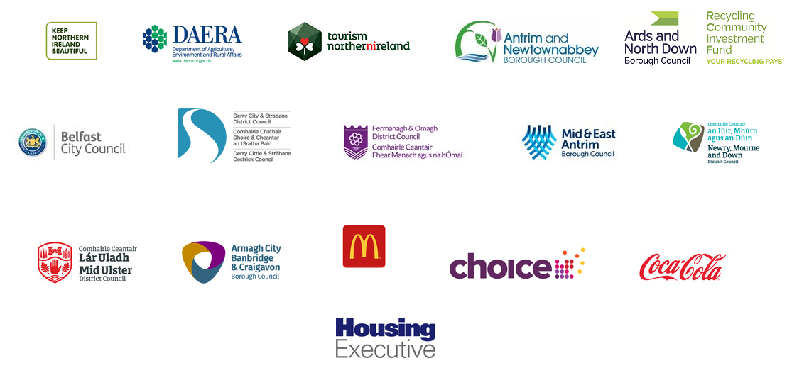

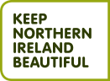
Keep Northern Ireland Beautiful
Phone: 028 9073 6920
Email: smallgrants@liveherelovehere.org
Web: www.liveherelovehere.org
The Live Here Love Here Small Grants Scheme forms part of a wider programme aimed at promoting civic pride within communities and improving environmental quality. The Small Grants Scheme is a partnership between Local Councils, the Department of Agriculture, Environment and Rural Affairs, Choice Housing, Northern Ireland Housing Executive, McDonald’s and Keep Northern Ireland Beautiful.

“Civic and community pride means taking our responsibilities as seriously as we value our rights. The result: we get out there and make our environment a better place to live.”

Ian Humphreys, Keep Northern Ireland Beautiful

The small grants scheme aims to enable and support volunteers to:
- Improve the quality of their local environment by reducing littering and dog fouling through effective and innovative means;
- Enhance the environmental management of a local area;
- Contribute to the development of civic pride within a community with a focus on environmental improvement.
- To enhance or attract tourism to their community through environmental improvements.

- Eligibility
The Live Here Love Here Small Grants Scheme is open to:
- Volunteer, community groups and NGOs
- All schools and third level education organisations
- Youth groups and sports clubs
- Not for Profit Organisations
To be eligible groups should be:
- Embedded in their local community,
- Primary aims and objectives focused on benefiting the community,
- Aim to reduce littering and dog fouling through effective and innovative means and/or
- Attract tourism to their community.
The scheme can only accept general applications from groups delivering projects within the boundaries of the following Council areas:
- Antrim and Newtownabbey Borough Council
- Ards and North Down Borough Council - Recycling Community Investment Fund
- Armagh City, Banbridge and Craigavon Borough Council
- Belfast City Council
- Derry City and Strabane District Council
- Fermanagh and Omagh District Council
- Mid and East Antrim Borough Council
- Mid Ulster District Council
- Newry, Mourne and Down District Council

However, there are special allocations for groups delivering in any Council area if the project is in an area managed by a Housing Association/ Housing Executive. (Funding provided by Choice Housing, Northern Ireland Housing Executive and McDonald’s)

Value of Grants Awarded
Grants will be awarded between £500 and £5,000. Higher levels of funding are only likely to be awarded to outstanding projects.
The judging panel reserves the right to change funding bandings if required and the above is provided as a guide only. Please note: The total grant amount distributed to projects within a participating Council area will be in proportion to the funding contribution made by that Council to the scheme.
A group can make more than one application. There is no requirement for groups to obtain match funding for projects.
What type of projects will the scheme consider?
Proposed projects must engage volunteers and community groups to deliver practical action and must meet one or more of the following objectives:
- Improve the quality of their local environment;
- Reduce litter and/or dog fouling in their local environment through effective and innovative means;
- Develop the environmental management of a local area;
- Instil civic pride within a community provided the focus is on environmental improvement;
- Relate to environmental improvement in coastal areas or inland waterways;
- Improve/attract tourism to their local area.
Applicants should note that they do not need to meet all the objectives of Live Here Love Here; but in their application they should strongly indicate those objectives that they do meet.
The Small Grants Scheme is open to all groups including those which have previously received grants through the scheme. Partnership working is strongly encouraged.
Projects will be assessed in the following areas: environmental outcomes; project goals; project need; volunteer involvement; partnership working; long term impact; value for money and leverage.
What the scheme won’t fund
The primary focus of the Live Here Love Here Small Grants Scheme is to equip and support volunteers and community groups to deliver practical environmental action in their locality.
Applications to the scheme will not fund translation, arts/murals and awareness-raising or communication projects. An element of communication, for example, a leaflet to promote a clean-up event, will be considered only if it is part of a wider project.
Due to the focus on volunteering, the scheme will not fund rent, insurance, running costs for volunteer groups, salaries, staff time, administration or project management fees will not be considered.
Site visits
During project delivery, Keep Northern Ireland Beautiful and/or other investing partners may contact participating groups to arrange site visits to monitor the progress of their project(s).

- The Application Process
Completed applications must be submitted to Keep Northern Ireland Beautiful by 12 noon on Wednesday 21st June 2017. Applications received after this deadline will not be considered.
Please email your completed application to:
smallgrants@liveherelovehere.org

Alternatively, print and post to:
Small Grants Scheme
Keep Northern Ireland Beautiful
Bridge House, 2 Paulett Avenue
Belfast
BT5 4HD
Please note that proof of posting is not proof of receipt.
You will receive an email confirming receipt of your application and Keep Northern Ireland Beautiful will contact you directly after your application has been assessed within 4 weeks.
Applicants must not change the format of the application form.
Please submit your completed application form in word format, PDF documents will not be considered.
Additional documents will not be considered.
Timescale for Live Here Love Here Small Grants Programme:
Funder | Deadline
Applications Submitted by | 12 noon on Wednesday 21st June 2017
Assessment completed and Letters of Offer sent | Friday 7th July 2017
Projects Completed & Financial Claims Submitted | 12 noon 8th January 2018

- Claiming Your Grant
Partial payment of Grants will be available and funding will be released upon confirmation that elements of the project are complete. Groups should contact Keep Northern Ireland Beautiful if they expect to experience cash flow problems.*
All financial expenditure must take place and claim forms must be submitted to smallgrants@liveherelovehere.org by noon on 8th January 2018.
All purchases must have at least two written quotes.
Failure to comply may result in grant funding being withheld or withdrawn.
Claim forms will be circulated to successful projects during July 2017.
*In exceptional circumstances partial payment of grants will be paid in advance (80% of funding upfront and the final 20% will be paid on receipt of a completed and satisfactory summary report), where groups paying for goods will create hardship. This will be assessed on a case by case basis and only where the relevant additional information has been supplied to Keep Northern Ireland Beautiful. A member of staff will be in touch to discuss details and to finalise the assessment.

Live Here Love Here Small Grants Scheme - Application Form 2017
(Please read the guidance notes before completing this application form. Do not alter the format of this form and use only the space provided)
Section 1: Applicant’s Details
Name & Address of Group:
Project Leader:
Email Address:
Phone Number:

Section 2: Project Details
Project Title (max 6 words):
Project Location:
Council (must be a participating council):
Is this project in an area managed by a Housing Association or Housing Executive? | YES/NO
If Yes please state the name of the Housing Association or Housing Executive:
Is this project in a coastal or inland waterway area? | YES/NO
Project Description (150 words):
What is the overall goal of your project? How will your project help to build Civic Pride? (100 words)
What evidence have you collected to demonstrate the need for your project? (100 words)

Who will benefit from the project and how? (100 words)
How does your project meet the objective(s) of Live Here Love Here? (150 words)
How many community groups/volunteers/partners will be involved in project delivery? (100 words)
How far is the project led by volunteers and how do you recruit, train, support and recognise the volunteers who will be involved in the project? (100 words)
What is the estimated timescale for completion of your project?
Does your project require permission from a third party, if so who? Has permission been obtained? All permissions must be granted before the project begins. | Do NOT leave this space blank
Do you intend to maintain your project in the longer term and if so, how? (150 words)

Have you previously received Live Here Love Here Funding? If yes, please explain. (50 words)
Have you previously been involved in Live Here Love Here programmes? Please tick all that apply
Adopt A Spot
Big Spring Clean
Clean Coast Programme
Shown Support on Live Here Love Here website (www.liveherelovehere.org)
Keep Northern Ireland Beautiful may wish to use your project to promote Live Here Love Here and the small grants scheme through the media and other communication channels. Please tick this box if you do not wish details of your project to be used in this way 
If you do not wish to be contacted in the future by Keep Northern Ireland Beautiful
please tick box 

Section 3: Project Costs
What is your overall project budget? ___________________
How much are you requesting from the small grants scheme? ________________

Item | Total Cost | Amount requested from the small grants scheme

What contribution, if any, are you making to your project?
Funding
Volunteer Time (Days)
Other
I understand that it will be a condition of the grant that it will be used for the purpose for which it was awarded. I undertake to use the award only for that purpose.
Signature……………………………………………… Date…………………………………………………
(A typed signature will suffice for the submission of the application form via email)

Please remember to keep a copy of this application form for your own records.

Thank you for your interest in the Live Here Love Here Small Grants Scheme

